Children’s book author/illustrator Kristi Valiant is visiting our school!
On _____(date)______, author/illustrator Kristi Vailant will visit our school. Kristi will autograph her books and write your child’s name in fancy letters. Please return the completed form with payment (cash or check) by _____(date)____. Make checks payable to __________. Thank you!

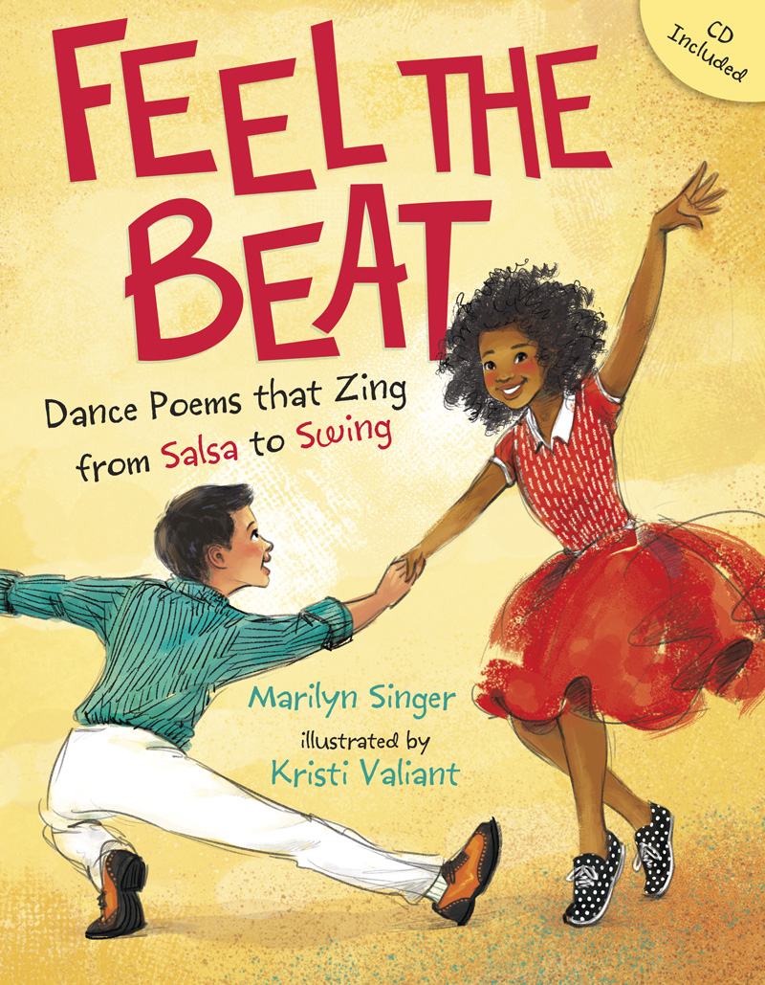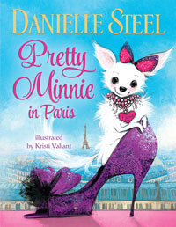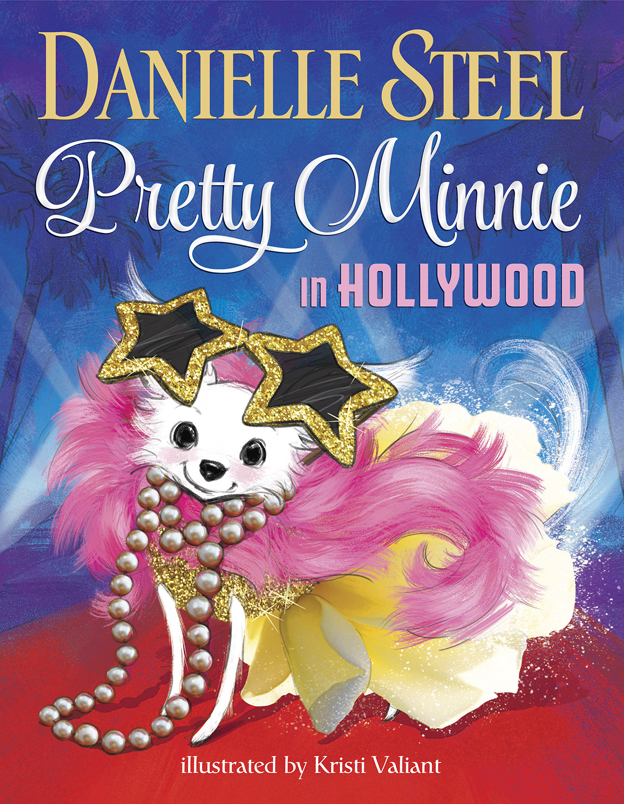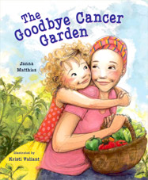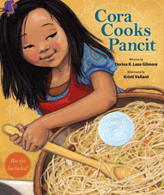

FEEL THE BEAT: DANCE POEMS THAT ZING FROM SALSA TO SWING: An irresistible book of poems about dancing that mimic the rhythms of social dances from samba and salsa to two-step and hip-hop. Included with the book is an audio CD of the author reading each poem. Written by Marilyn Singer, illustrated by Kristi Valiant, 32 pages.
PRETTY MINNIE IN PARIS: From #1 New York Times bestselling author Danielle Steel comes a charming picture book about Minnie, a tiny Chihuahua with big style! Written by Danielle Steel, illustrated by Kristi Valiant, 32 pages
PRETTY MINNIE IN HOLLYWOOD: Lights, camera, adorable! Pretty Minnie is back, and it’s her big break when she visits the glitz and glamour of Hollywood! Written by Danielle Steel, illustrated by Kristi Valiant, 32 pages.
THE GOODBYE CANCER GARDEN: Janie’s mom has cancer. When the doctor says that Mom will probably feel better by pumpkin time, Janie suggests they plant a garden. As the healthy veggies grow, Mom grows healthier. This is a hopeful story of recovery. Written by Janna Matthies, illustrated by Kristi Valiant, 32 pages.
CORA COOKS PANCIT: When Cora’s older siblings head out for the day, Cora gets the chance to be assistant chef. She chooses to make her Grandpa’s pancit recipe, a Filipino noodle dish. Recipe included. Written by Dorina Lazo Gilmore, illustrated by Kristi Valiant, 32 pages.

TITLE | PRICE | QUANTITY | TOTAL | NAME TO BE INSCRIBED IN BOOK
FEEL THE BEAT | $
PRETTY MINNIE IN PARIS | $
PRETTY MINNIE IN HOLLYWOOD | $
THE GOODBYE CANCER GARDEN | $
CORA COOKS PANCIT | $
Total Amount Enclosed

Student’s Name:
Teacher’s Name:

